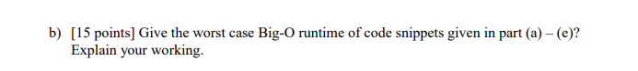

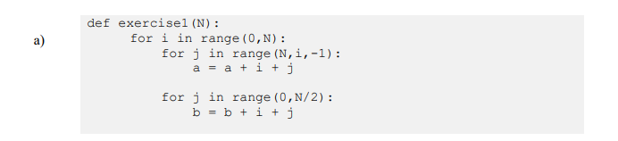

**The parent for loop = N**

**First inner for loop = (N+1)/2**

**Second inner for loop = N/2**

**N * [(N+1)/2 + N/2]**

**N^2 + N/2 (ignore the less significant)**

**O(N^2)**

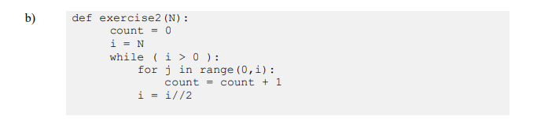

**Using the Geometric Series formula we can deduce**

**N(1/(1-(1/2))) = 2N**

**O(N)**

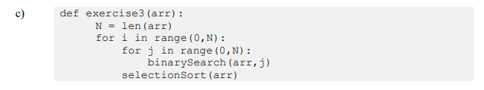

**Complexity of Binary Search = O(logN)**

**Complexity of Selection Sort = O(N^2)**

**Parent for-loop = N**

**-Inner for loop = N**

**-Inner Binary Search = logN**

**-Selection Sort = N^2**

**N * (NlogN + N^2)**

**N^3 + (N^2)(logN) -ignore the less significant**

**O(N^3)**

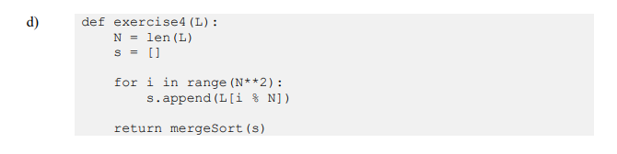

**For-loop = N^2**

**Mergesort = O(NlogN)**

**N^2 + NlogN (ignore the insignificant)**

**O(N^2)**

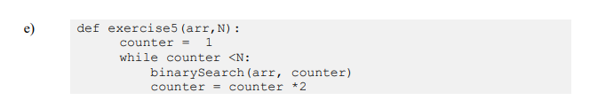

**While loop = logN**

**Binary Search = logN**

**logN * logN**

**O(logN)^2**